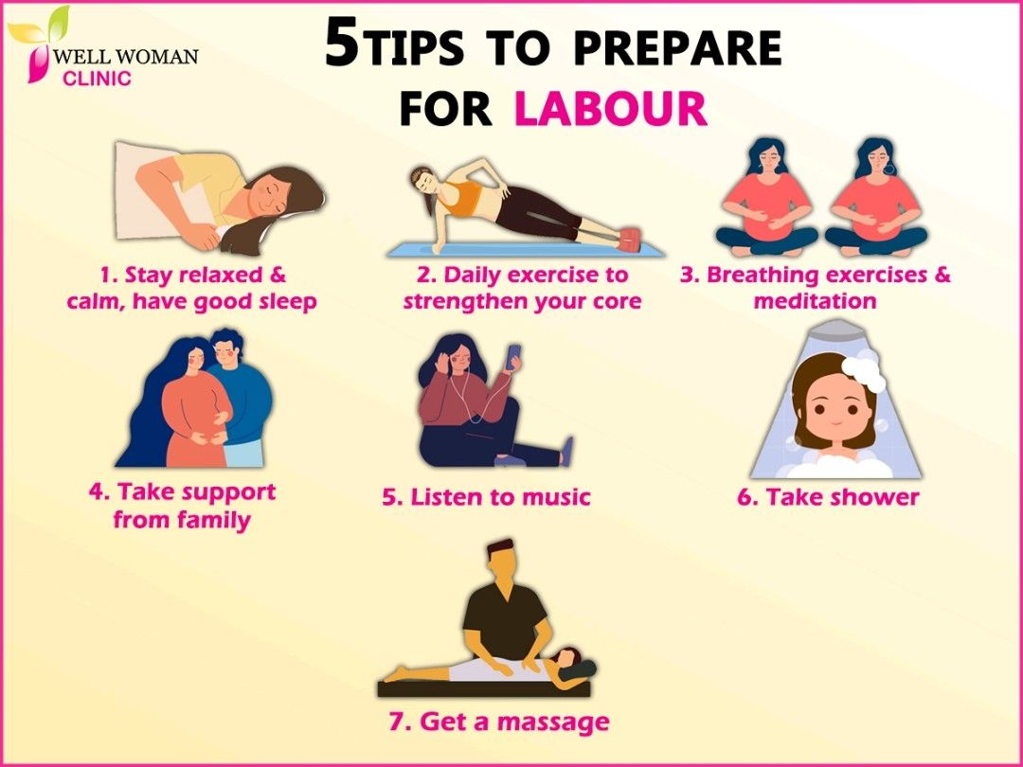

Five tips to Prepare for Labour  
1. Stay relaxed & calm, have a good sleep  
2. Daily exercise to strengthen your core  
3. Breathing exercises & meditatiom  
4. Take support from family  
5. Learn ways to cope in labour: listening to music, taking a shower or getting a massage